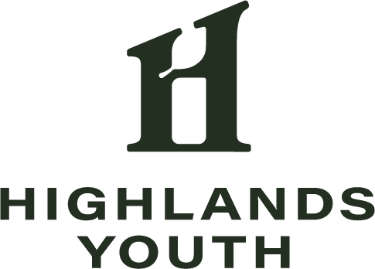
Highlands Youth Advisory Board
Established in 2013, The Highlands Youth (HY) Advisory Board is an advisory board to the community building work of Highlands Council, providing youth a voice in community matters. The Mission of the HY Board is to unify Issaquah Highlands youth through meaningful and fun social experiences, creating lasting memories and building pride in our community. While social events have been paused for a couple of years, the HY Board looks forward to the return events (past events include the Halloween Party, Flashlight Egg Hunt, and End of School Year Night at the Carnival.) Past service projects of the HY include building eight of our ten Little Free Libraries, Parents Night Out babysitting events, and multiple community art projects. HY Board members may also participate in Highlands Council Board of Trustee meetings, and as members of Highlands Council committees such as branding, transportation, and cross-cultural. We invite any residents who will be in 7th through 12th grade in the 2022-2023 school year to apply for a position on the HY Board!

2022-2023 Highlands Youth Advisory Board Application

Note: Applications must be submitted online BY MAY 1
This document is to aid in preparing your answers to be entered on the form.

- Email Address
- First Name
- Last Name
- What is your birth date?
- In what grade will you be in Fall 2021?
- Where will you attend school in Fall 2021? (Name of school)
- What is your street address?
- What is your cell phone number (if you have one)?
- Please provide the name of a parent/guardian
- Parent/Guardian Cell Phone Number
- Parent/Guardian Email Address

What volunteer/work experience or extracurricular activities have you been involved in that may contribute to your success as an HY Board member?
If you are currently in middle school, feel free to answer this question instead… What volunteer service and/or extracurricular activities do you hope to experience in the future?

What talents and/or strengths would you share with the community through your involvement on the HY Board?

What issue are you most passionate about when it comes to the Issaquah Highlands Community? Do you have any ideas on how to address the issue this year?

If selected for the HY Board, which of these activities would you be most interested in working on? (Select up to 3)
- Putting on events for high schoolers
- Putting on events for middle schoolers
- Putting on events for elementary/younger kids
- Volunteering for community events
- Planning/participating in service projects
- Civic involvement (either with Issaquah Highlands or at the city level)
Please share ay ideas you have!

Anything else you would like us to know?

We will meet the 2nd Sundays of each month, September-May, from 2-4 p.m., at Blakely Hall. Expectations are that you will attend at least 7 of the 9 meetings planned for the school year to remain in good standing. Members are also expected to participate in planned events and service projects, in addition to meetings specific to committees or events, including a team building event on Saturday, August 20. The total time commitment varies, but members should plan on 3-10 hours per month during the school year. Additional opportunities to volunteer will be available over the summer and through the school year.

If selected, will you be able to honor the commitments required to serve on the HY Board?

